Ecological Agriculture – Climate Change Adaptation Workshop

**Kompiam Agribusiness Women Date 14/03/25**

Community Development Workers Association

PO Box 1032 Goroka 441 EHP, PNG. Ph: 78270106, **cdwai.net**

David Kulimbao, Team Leader Email: [dkcdwai@gmail.com](mailto:dkcdwai@gmail.com)

Anna Kulimbao, Child Safety and Women’s Officer

Ben Heyward, Project Design and Evaluation: [benhey37@gmail.com](mailto:benhey37@gmail.com)

**Strengthening Rural Communities Small-Medium Enterprises Food Security and Climate Change Adaptation Workshop, 12 – 15 March, Red Corner, Laiyakama, Kompiam**

CDWAI, the Community Development Workers Association Inc. was established in 2011 as a non-profit organization to deliver community services to rural and remote communities in the Highlands, where Government services are lacking.

Since the cutoff of funding at the start of the Covid outbreak we have carried out community consultations and run workshops from our limited funds. We work in partnership with overseas donor agencies, national and provincial government and local civil society organization.

Kompiam Agribusiness Women formed because of the importance of producing their vegetables and cash crops like, pineapple, peanuts, taro and bananas. They say, “We want to build our family livelihoods by maintaining and building the fertility of our mountain gardens through adapting new and restoring traditional Ecological Agricultural practices.

The CDWAI team supports local groups to strengthen family food security and cash cropping. We help families to modify their gardening for restoration of soil fertility, prevention of soil erosion and keep their gardens alive during drought. This will enable them to increase family income from cash crop marketing and also to preserve food for emergencies like drought, landslide, bush fire and flooding when gardens are damaged or destroyed.

**Day 1, Wednesday 12 March 2025** Discussions of:

1. Food security

After welcomes and introductions we opened by asking the women how well their gardens were growing and what problems they were experiencing. They answered saying:

* Rainstorms bigger than ever before are happening
* Many short droughts, especially around planting time, are killing or spoiling crops
* We have heavy insect infestations, like kaukau weevil, and disease outbreaks like black spot

2. Land management

We discussed how tethering pigs in old gardens for a long time causes great loss of topsoil, ‘yuu kungun’, from heavy rain. The CDWAI team then said that topsoil could be restored on spoiled red ground by planting Waima, Mari Mari (Acacia falciparum), Lantoro (Leucaena), Crotalaria, Tephrosia, Stylo, Desmodium, Centrosema and Wild Sunflower which are all growing wild around Enga. In the future as population increases people will find that keeping fewer pigs but with some goats to graze on fallow land will reduce soil erosion.

Women described how at our 2014 Ekolosi Kibung at Alukapaise they had made a Community Agreement to only burn bush after cutting everything down to make a new garden and they planted many trees around their houses, the church and the meeting ground. The also changed to digging their drains along the contour instead of straight down the slope.

3. Soil management - Agroforestry

In the past David and Anna showed some of these women how much topsoil they had lost from their gardens and that they by putting garden trash in the drains, and digging holes in the drains, they could trap eroded topsoil then shovel it back onto the garden beds. At morning tea we demonstrated this and also planting Wild Sunflower and Crotalaria or Tephrosia cuttings close together, in a line along the lower edge of garden beds also to keep topsoil from washing off into the drain.

4. Seed storage and testing

The women brought seeds from home as David had requested. He showed them how weevils had destroyed many of the corn (kenapa) seeds and that many of the bean seeds were rotten because they had not been fully dried. He showed the women how to test if seeds were still too wet by putting some seed in a plastic bottle in the sun for 30 minutes. If the bottle then had water droplets in it or was cloudy the seeds were still too moist.

5. Food preservation

Anna and David demonstrated both grating and slicing of cassava (sweet potato and taro can also be used), drying in the sun then storing in airtight containers like large jars, plastic bottles or even 20litre buckets. The sliced cassava must be boiled for 3 minutes to soften it so that when it is to be cooked it is also soft to eat. Cassava (tapioc) stored in this way can keep for over 10 years to be used in ‘taim hangri’.

6. Dead leaves and plant stalks for compost

We talked about the compost Enga women use when preparing their large and small sweet potato mounds.

* Anna emphasized using lots of fresh leaves or stalks with dried plant material
* David and Ben explained that old sweet potato tubers and runners should be heaped up and burned to kill all weevil eggs and larvae that could infest new sweet potato mounds
* Spread the ash from those fires over the mounds or other garden beds when rain is coming
* Never use old tubers or runners for composting. If you do that you yourself will infest your sweet potato mounds with sweet potato weevil so that your new tubers will be spoiled by the larvae (pombata)

**Day 2, Thursday 13 March 2025**

Explanations and discussion

1. Integrated pest and disease management

There are 2 important ways of controlling insect pests (and mites) in gardens

1. Plant crops together so that one kind of food plant, like Ginger with Turmeric (Taka), keeps pests like White Butterfly away from cabbages and cauliflower. Plant Marigolds between Pineapples and Tomatoes, Capsicums, Pumpkins, Potatoes & Beans to reduce nematodes (flatworms). Plant beans with cabbages or cucumber (auwaka). You might read that these plant partners are called Companion Plants, meaning that they are planted together.
2. We spray plants to kill or repel (drive away) pests. But chemical poisons from stores like Chemica or Farmset costs big money and can be dangerous to people eating the cabbages or tomatoes if you sell your crop soon after spraying.

We can make our own sprays. Soak (steep) Crotalaria (Yellow Flower), Tephrosia (White Flower), Muti (Burusi, Tobacco) leaves in water for 4 days, strain the water through a clean rag or a sieve (strainer) then add ½ a cup of pure soap chopped up and dissolved in hot water. Do not use washing or dishwashing liquid only pure soap.

You can try chopped up chilli, turmeric, ginger or poison bean leaves (fish poison) from the bush to spray on pests or add them to the Crotalaria, Tephrosia or Muti insect-killer.

Mix 1 cupful of your insect-killer with 1litre of clean, pure water for your 1 litre spray bottle or 2 cupfuls for a 2 litre bottle or 10 cupfuls for a 10 litre backpack sprayer.

2. Crop rotation

If you plant the same food crop in the same garden beds over and over again from year to year or season to season you will allow the pests and diseases of that crop to survive from year to year in the soil or nearby plants. The numbers of pests and disease viruses, fungus (pusi) or bacteria will all increase so attacking your food crop more heavily.

* Change the crop in the garden bed every year, or at least 3 years in the case of pineapples or cassava, although you should keep some cassava crops in the ground for emergency food supply in drought, after flooding or fire.
* Potatoes, Chillis, Egg Plant, Sweet Potato and Tomatoes are all from the same family so after you harvest and finish those crops in those garden beds plant beans, corn, kunyi or cabbages, crops from other families. Tomato family plants do suffer from many diseases and insect pests, like root-rot and flatworms (nematodes). Starve the pests by taking away the plants they feed on. Flatworms are very tiny. You need a magnifying glass to see them.

1. Local food security and health

We asked the women what plants would withstand drought so that the family would still have food to eat when crops like sweet potato stopped growing or died during and after the bik-san drought. These are the food plants they listed as best for surviving and growing:

Cassava, Taro, Kena Kalapo and Mase Bananas, Amu Kiyape and Muliki (local Yellow and Purple Yams) and African Yam, Sak Sak at Lapalama and Yangisa, Karuka, Nambis (Wara Kari ie Watercress), Alyungu Pyange (As Bin, Wing Bean), African Cabbage (a Cowpea variety), Wante (native riverside climbing bean) and Kauma (Opena, Yokwate in Sau Enga).

The women understood that these are food crops that they need always to have growing in their gardens. Having many fresh food crops for staples, protein and green leaves keeps the family healthy, especially children.

1. Weed control

Weeds grow from their seed waiting in the soil for a time when they are uncovered and there are empty spaces in the garden. If you leave weeds to grow, flower and set seed (make seed) then even more weeds will grow in your gardens.

The first way to control weeds is to weed each garden bed before the weeds set seed and the seeds drop into the soil.

Planting 2 or 3 crops together, like companion plants, to control or repel insect pests will take away space, water and nutrients (plant foods in the soil) from weeds.

Covering garden topsoil with dry and fresh leaves is called mulching. Mulching will also reduce the number of weeds that can grow in your garden. When you plant Wild Sunflower, Crotolaria, Tephrosia and Stylo along the lower edge of your garden beds you can cut them back to knee high as they grow. Placing those cuttings between the food plants in the garden bed will give you plenty of mulch to control weeds and rot down to fertilize the soil.

**Day 3, Friday 14, March 2025**

1. Mulching to Restore soil fertility and stop Sweet Potato Weevil infestation

1. Composting sweet potato mounds enriches (fertilizes) the soil so that you harvest more tubers. You can also compost Taro, Taro Kongkong, Yams, African Yam, Banana suckers, Choko and Aibika to increase fertility and the crop yield.
2. Mulching garden beds, and mulching sweet potato and other mounds, stops hot sun from quickly drying out the soil and helps control weeds. It is very important to keep sweet potato mounds or garden beds moist during dry periods. When the mounds dry out small cracks open up the soil so that mother beetles (Nene in Enga) can wal down through the dry soil to the kaukau runners and tubers where they lay their eggs. The eggs hatch into little grubs or larvae (Pombata) that eat the runners and tubers leaving their frass (their manure or shit) so that the sweet potato tubers are inedible. They rot.
3. As the leaves and cuttings you have used for mulch rots down it will also add nutrients to the soil making it more fertile. The mulch restores fertility that the food crops take from the soil.

2. Using animal manure

Animal manure is rich in nutrients (the plants foods in the soil) from the leaves and foodstuffs you feed to them, especially nitrogen and phosphorus that your garden soil needs.

* Pigs manure is very rich in nutrients like the salts of Nitrogen, Phosphorus and Potassium. These are the most important plant foods. There are many other nutrients that are only needed in small amounts
* Cow manure is rich in fibre which adds the element Carbon to soil. Soil needs Carbon for the soil to hold onto other nutrients so that rain does not quickly wash them away
* Rabbit manure and Goat manure are also full of fibre (fibrous) from the leaves and bark they eat
* Chicken manure (droppings), all bird droppings, are also rich in nutrients, especially Phosphorus
* Where topsoil has been washed away in Enga the red or yellow ground underneath (the subsoil) is often short of Phosphorus. Any manure will help to restore topsoil in gardens on red or yellow soil.

Putting animal manure into compost enriches the soil even more than leaves and stems

3. Evaluation: Feedback from Workshop Participant Women

David asked 7 women and 2 men the question, “What have you learned in this Workshop over the last 3 days?”

Here are their responses, most of the women were from Kompiam Central:

Lena Londe

I am very grateful that I came to this workshop. I have learned 3 big things:

1. I learned how to use my own urine for pest control. [Lots of laughs then!]
2. I used to tether pigs in my steeply sloping garden but now I have learned not to do this because I lose my topsoil
3. Now I will dig my drains across the slope not up and down.

Judith LaoLao, wife of the Kompiam RDO

This workshop has brought us a lot of new teaching for working in our gardens. These are long-term lessons for our families about garden management.

Tominame Mark

Bipo me save long rausim ol grass long gaden tasol nau I will stop burning the grass or throwing it into the bush. I will let it stay on the garden beds or mounds for rotting down into the topsoil.

Tukiyame from Yangisa

I have learnt 3 new ways to plant kaukau (so that the runners and tubers grow faster) and to mulch over the kaukau garden.

Minambane from Alukapaise

I use a post to make a hole for planting taro into a mound. Now I will cover over the new mound with Wild Sunflower leaves and also wrap the cut surface of the taro chip with Wild Sunflower leaves.

Makalimi Philip

Over 3 days of discussion I learned 2 new important ideas:

1. 3 new ways of planting kaukau and how the longer runners will establish more slowly than the short, 3 node runners
2. To cover the new sweet potato mounds with grass and leaves as mulch

Laeme Koni, former MCH Nurse

For me an important lesson was that instead of throwing store goods plastic bags around the yard or the road I will put them in a pipier hole then burn them as well as squashed down fish and meat tins.

Another 2 lesson2 were to tether my pigs on easy slope or flat land, not on my steep slopes, and to dig garden drains across the slope to prevent erosion of our topsoil.

Jutias LaoLao, Kompiam RDO, man

In our meditation David told us to be content. For me the message was no matter what little land I have, plant trees and bushes like Wild Sunflower and Tephrosia around it and on the garden edges. Make use of the land carefully to maintain family food security despite troubles that are coming from climate change.

Jonah Red Kona, husband of Janet Saumi, Red Kona, Kompiam Agribusiness Women Leader

We need this workshop to go out to every clan, to the people of every Ward Councilor in our LLGs. All these points we have discussed are very important for our future.

Finally, I am still unhappy and cross because during the last fight (2018-2020) our next clan neighbours burnt our old Red Kona Women’s Centre and stole all our food. I am getting old and slow at rebuilding the Centre.

Workshop Participants: Women 36, Men 6, Youth 1

After the workshop Janet Saumi and David delivered a summary of discussions to Margaret Potame the President of Enga Enda (Women) Anda (House) Association. She said: “We are very interested in our program. Please send your Workshop Report to us. We have never before heard about this program that you have already run around Kompiam, Yangisa and the Tsak LLG. We will let you know if we can ever run this workshop for other women’s groups around the 5 Districts of Enga.

The CDWAI team thanks the Enga Women’s Department for all their works of your assistance.

We look forward to hearing from you.

Compiled by: Virginia David, Accounts and Reports Officer 

**David Kulimbao Ben Heyward MA**

**Team leader – CDWAI Evaluation and Project Design**

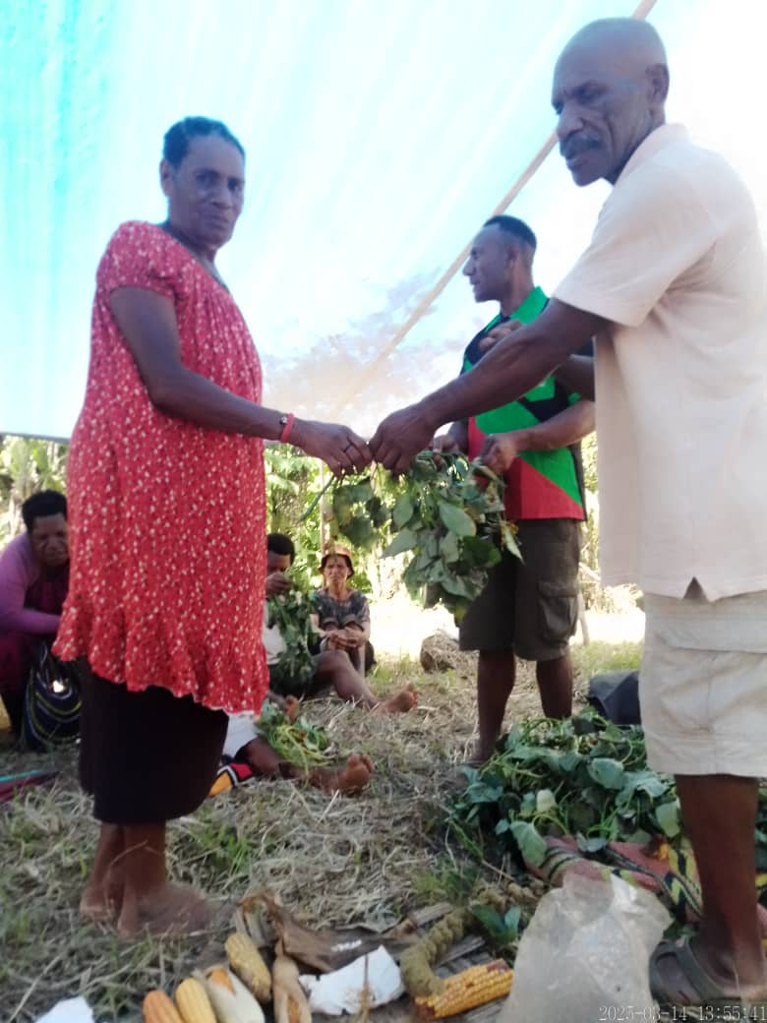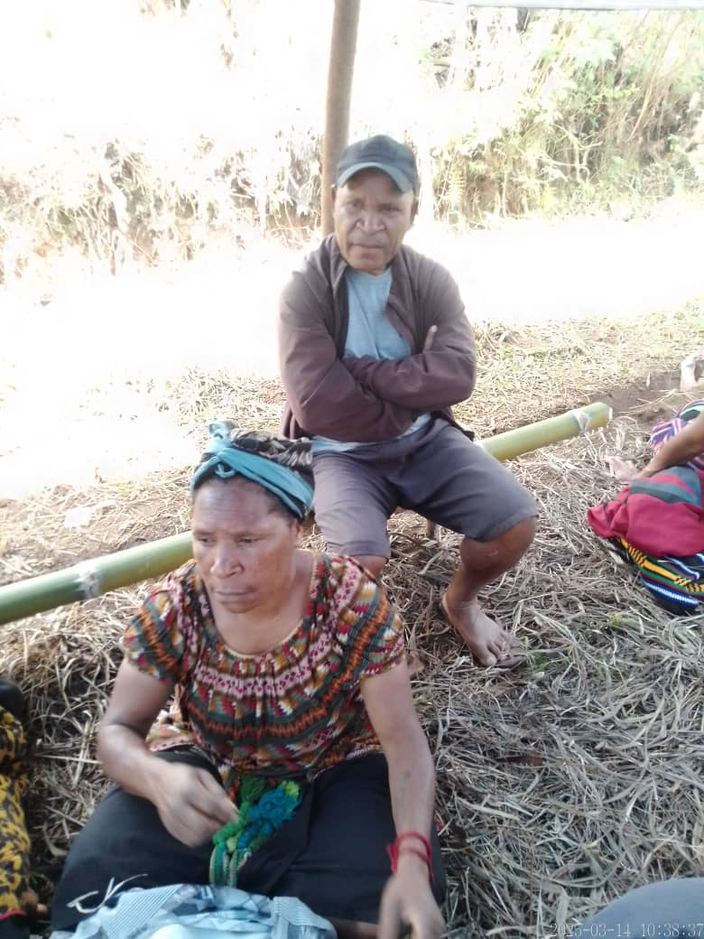

This woman is listening intently Presenting virus-free PT Deman kaukau runners

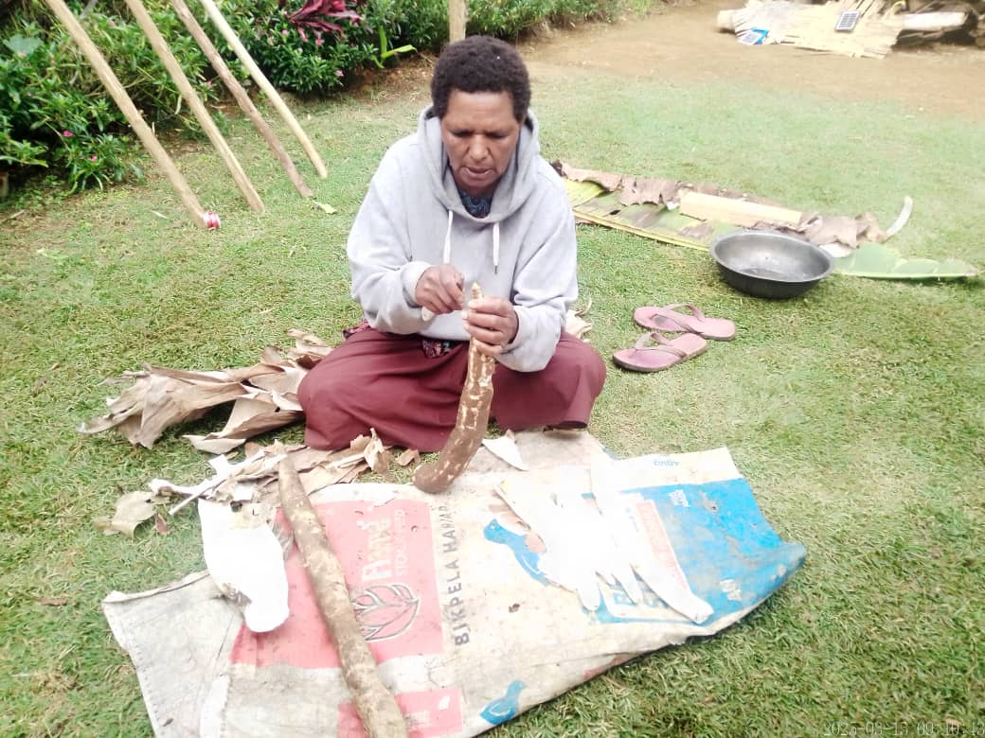

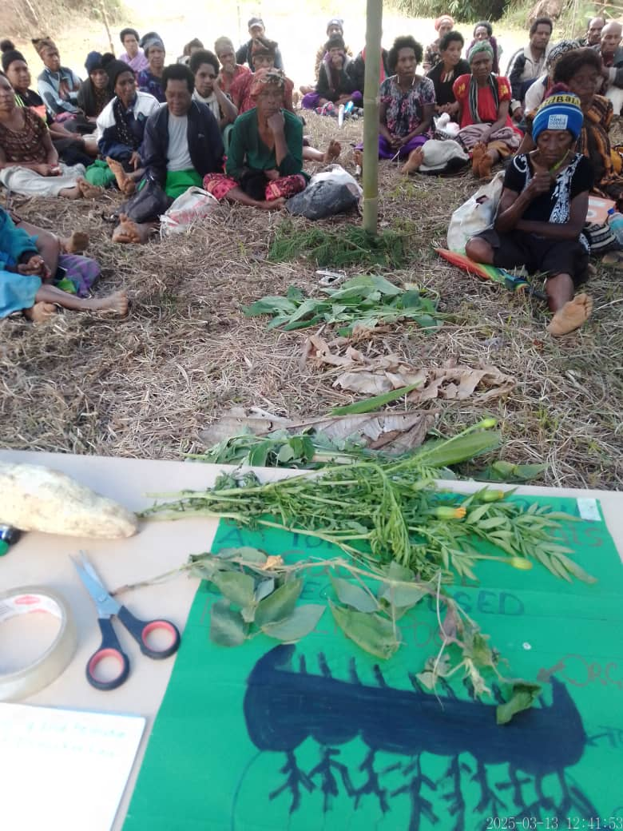

Showing the women different Red Kona legumes Anna Kulimbao peeling cassava for grating

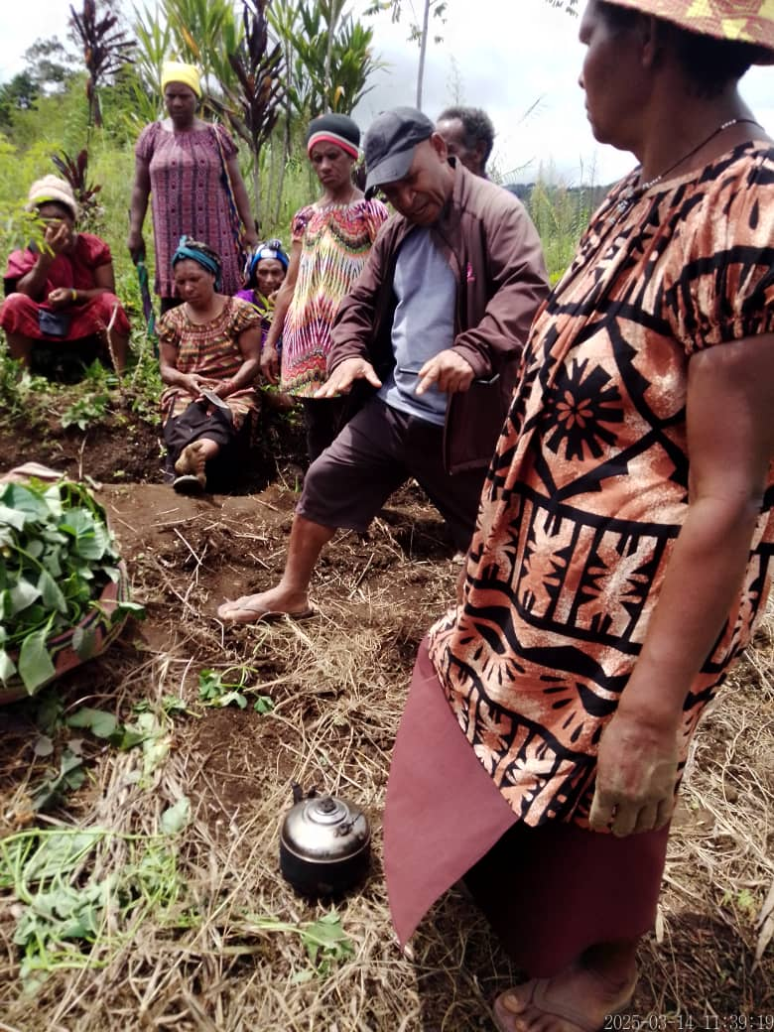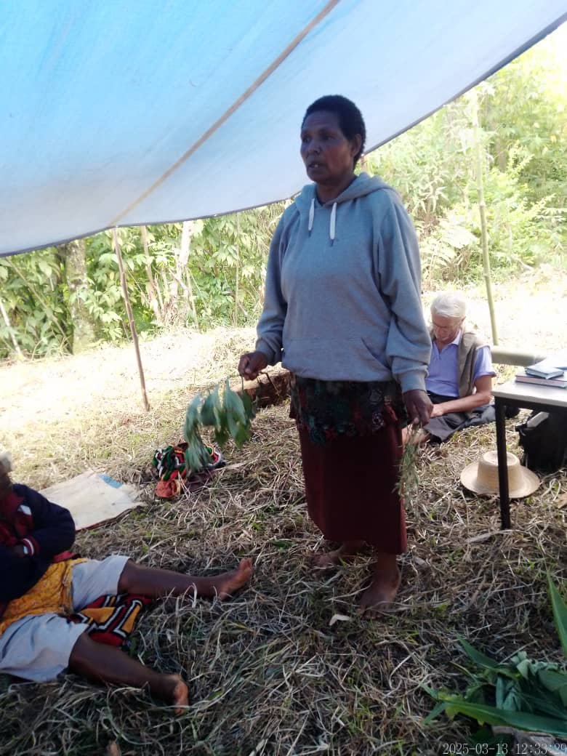

RDO Jutias demonstrating rain washing away mound topsoil

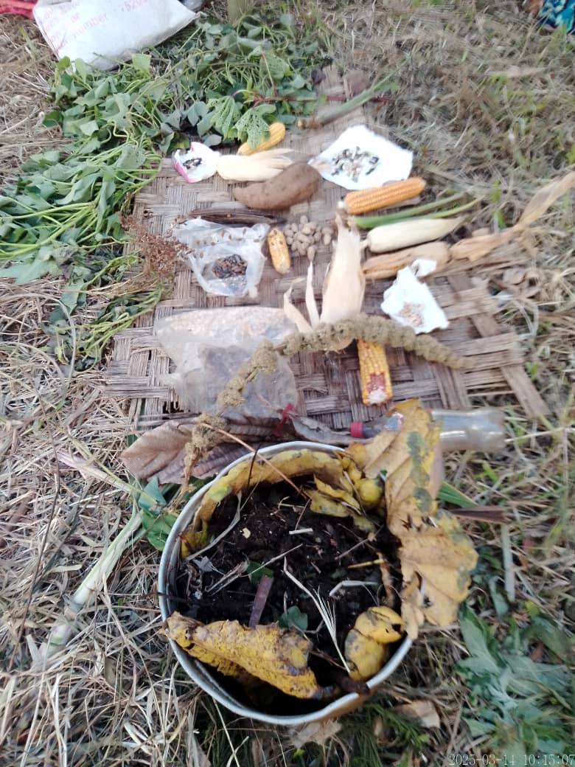

Anna showing 3 new ways of planting kaukau

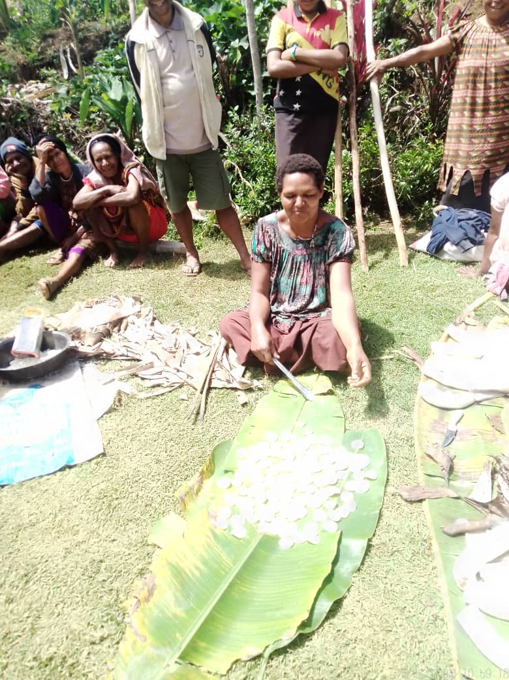 Pig manure for your garden!

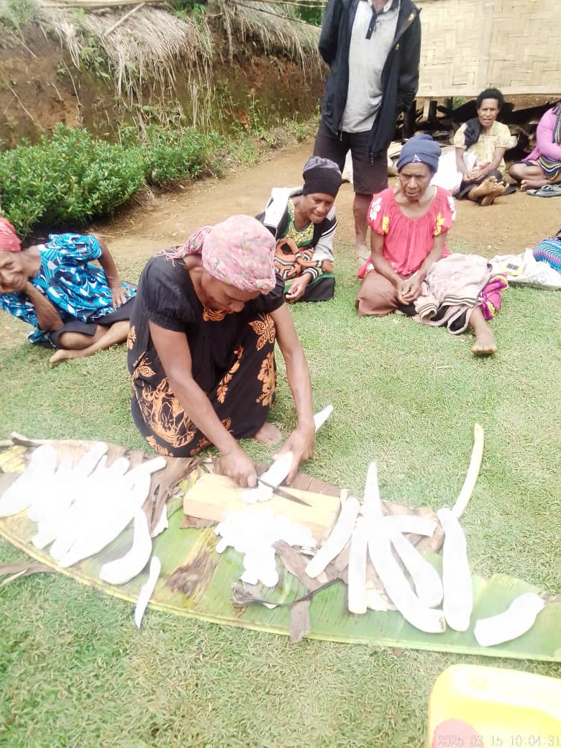

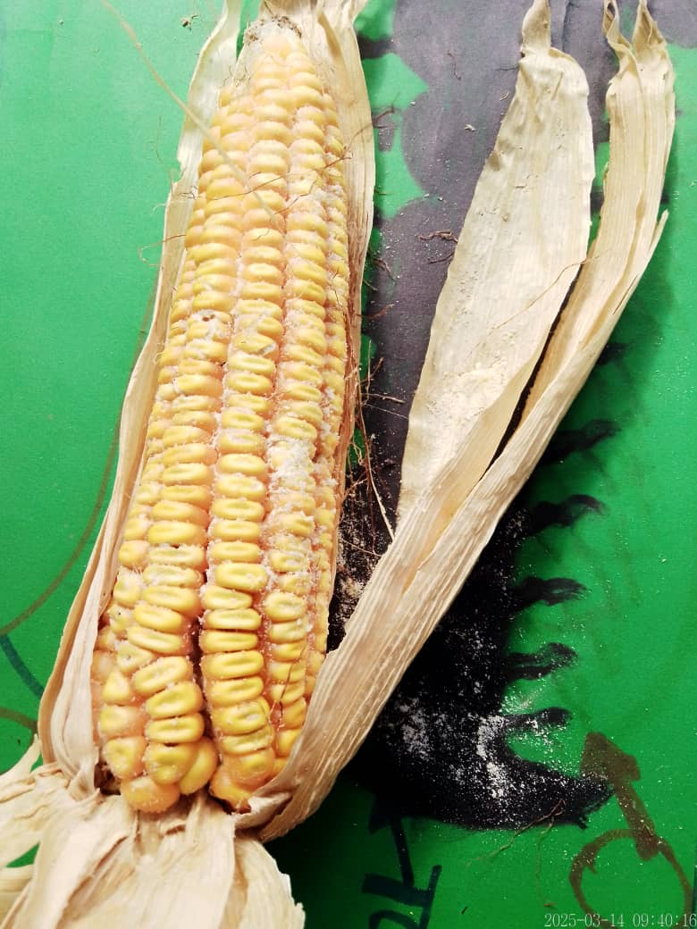 Anna squeezing cassava to remove water

Corn seeds on the cob ruined by weevils Participant slicing bande (cassava) for preserving

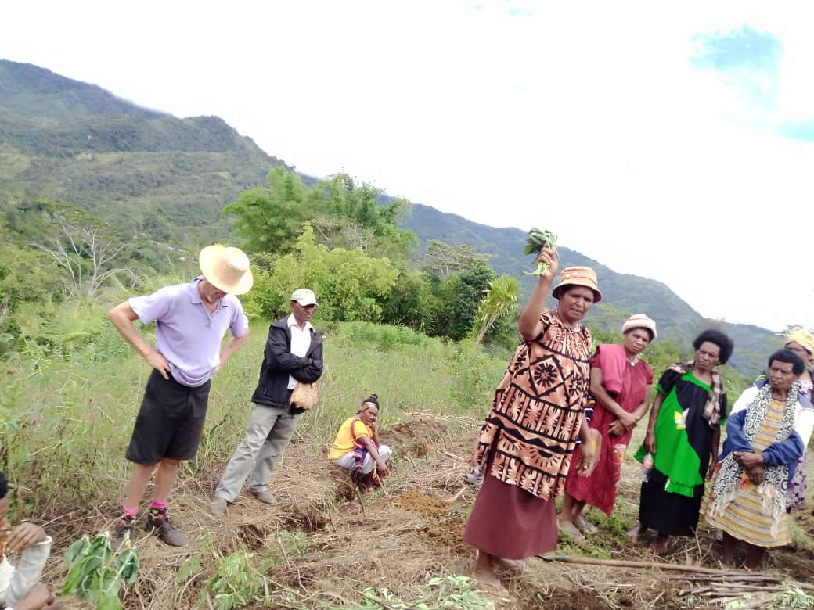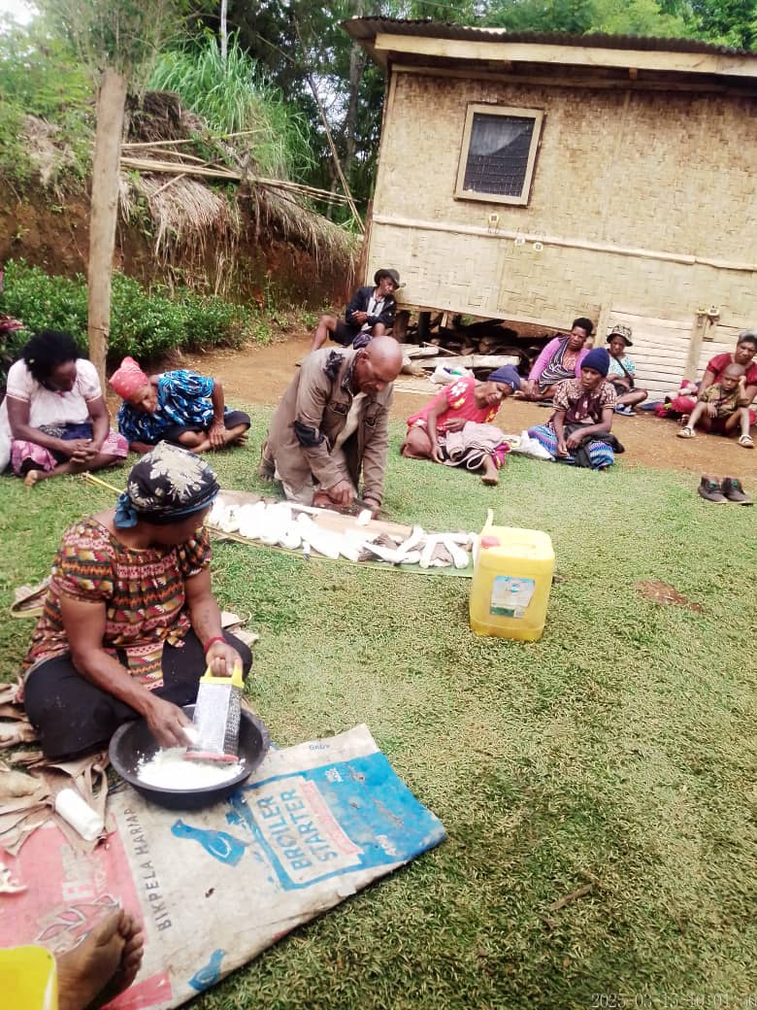

Tandame from Birip grating bande Anna showing planting with 3 node kaukau runners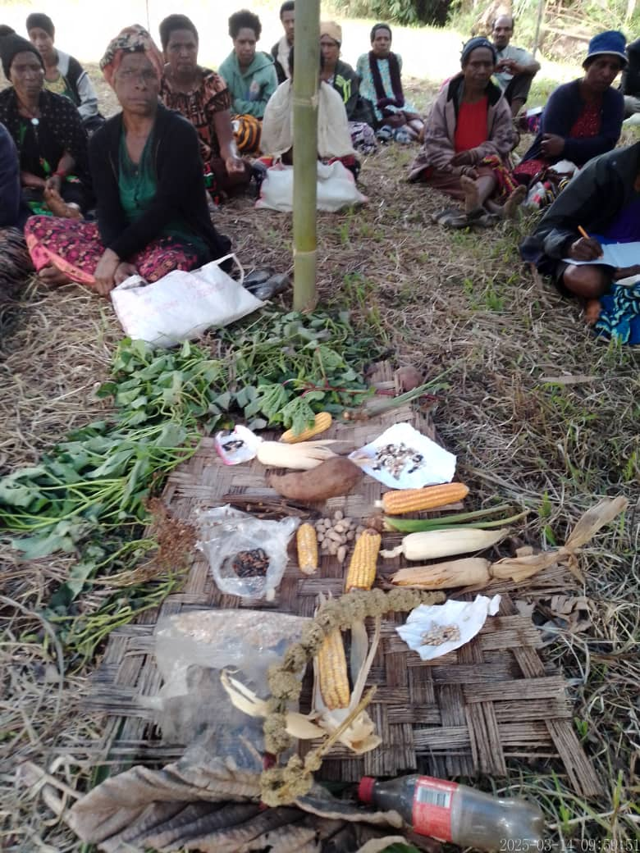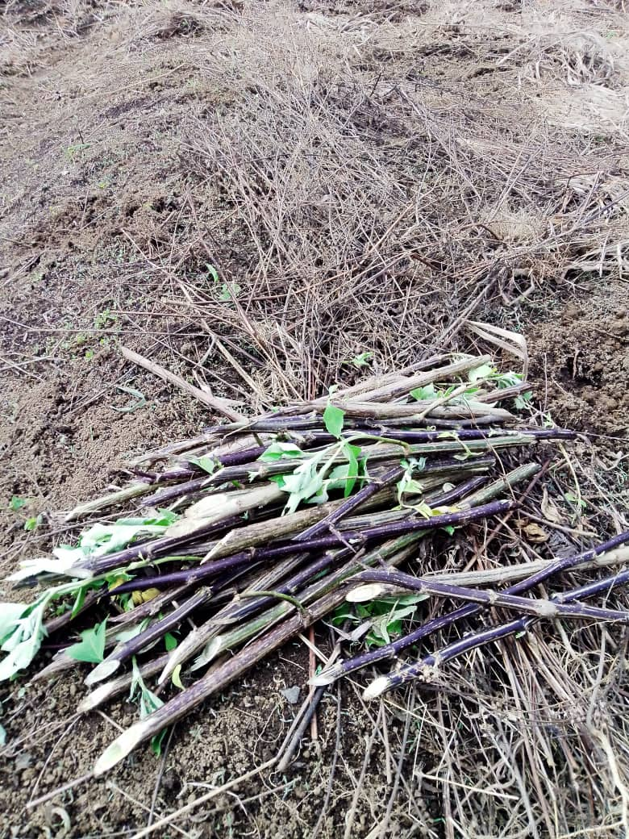

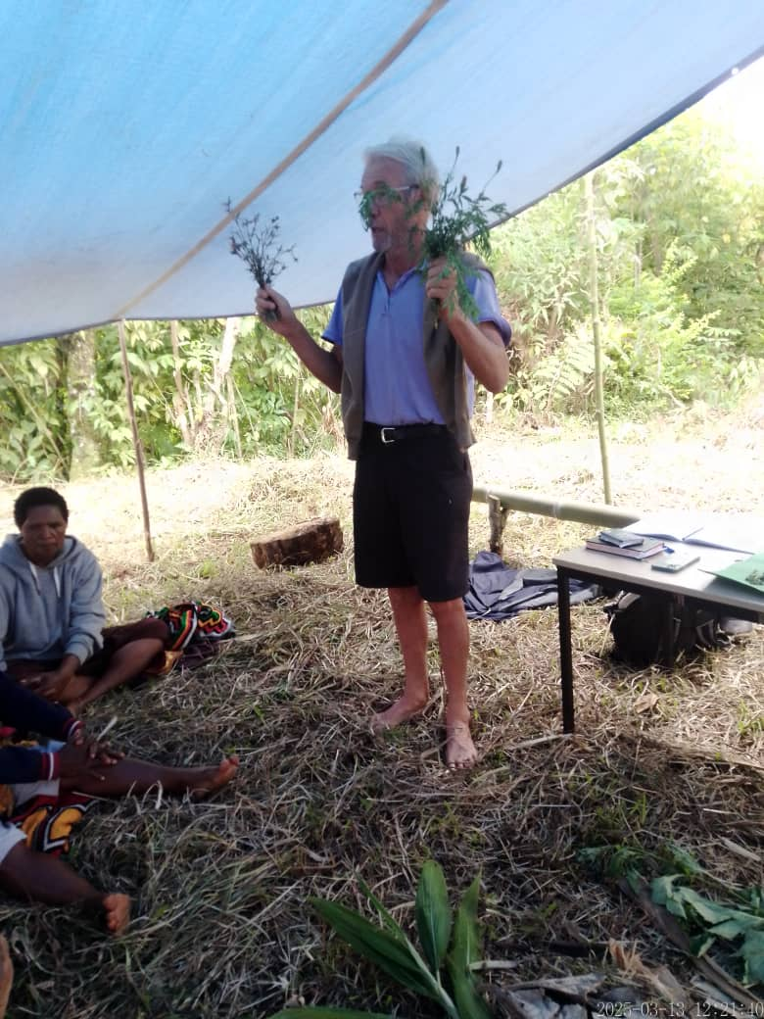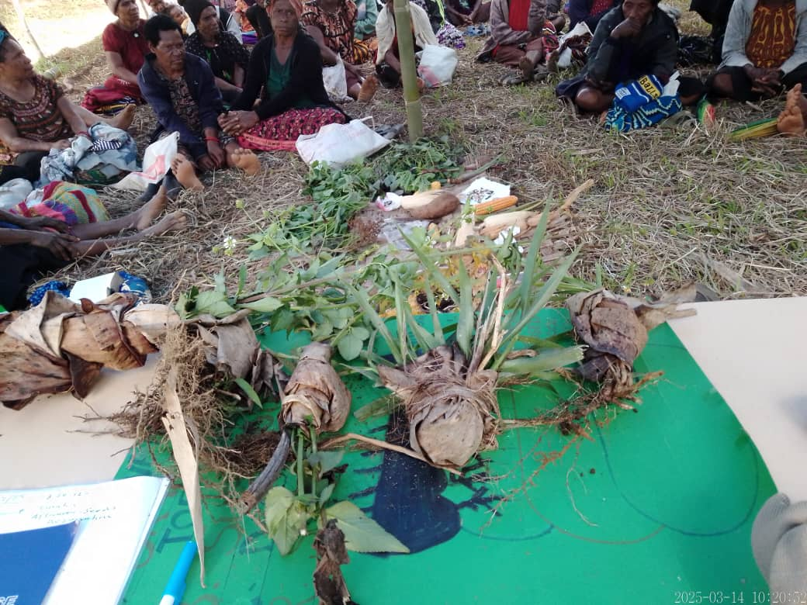Displaying all the seeds brought by the women Wild Sunflower stems for cutting up to plant

Common weeds of Kompiam Ben talking to the women about Tephrosia

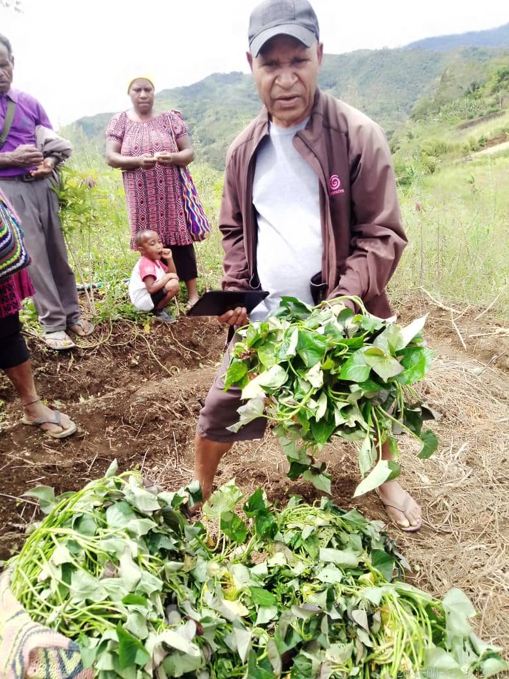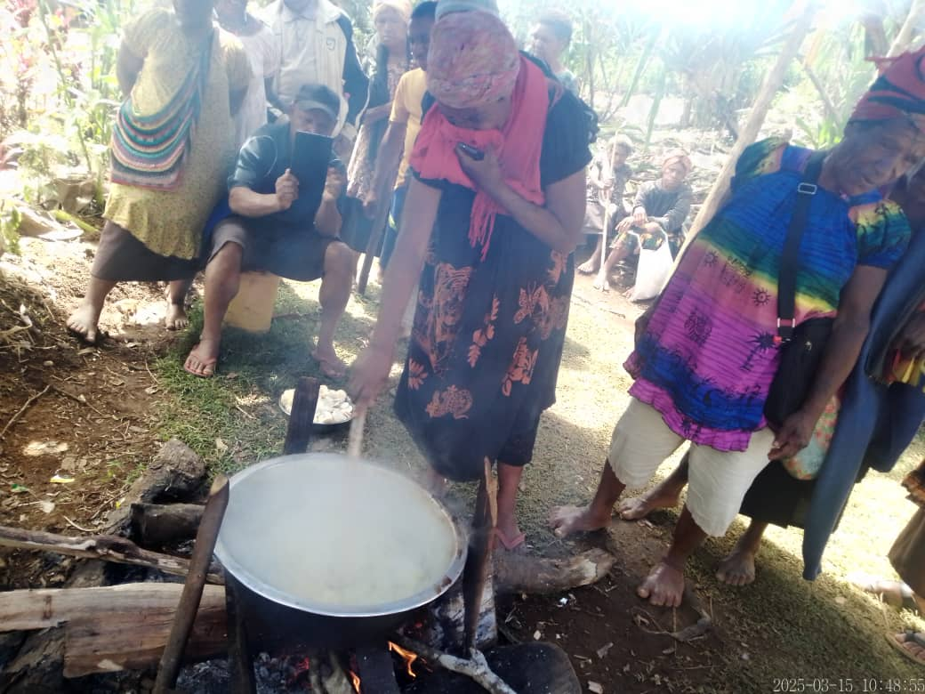

RDO Jutias distributing Deman virus-free kaukau Woman stirring cassava chips to soften for storing

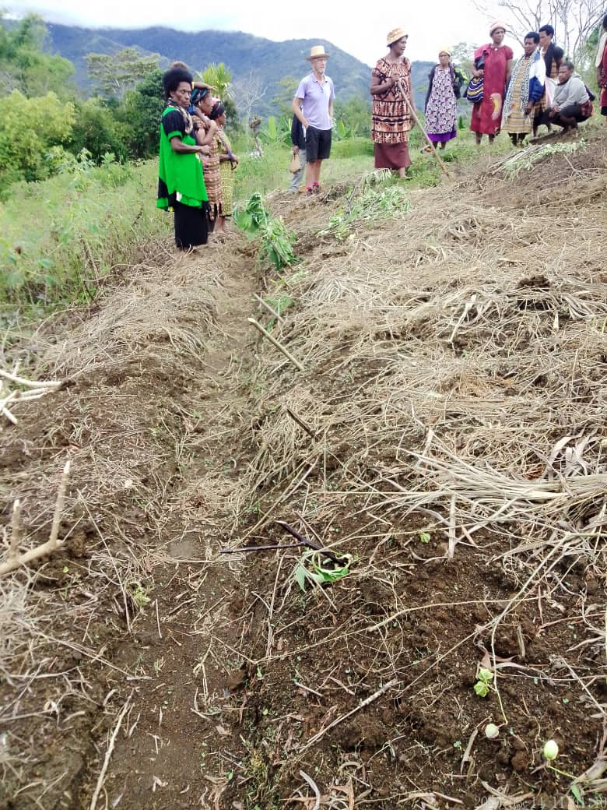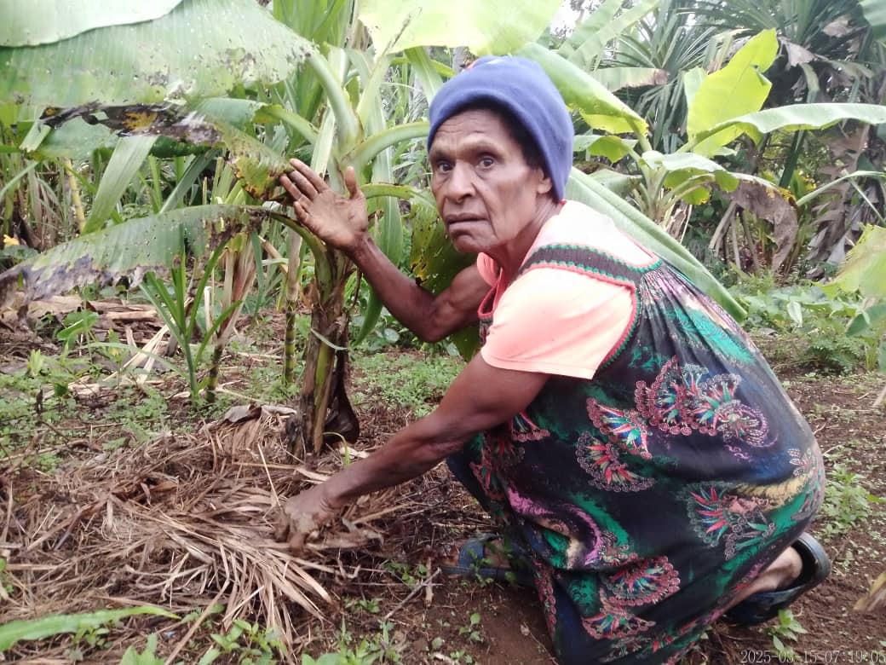

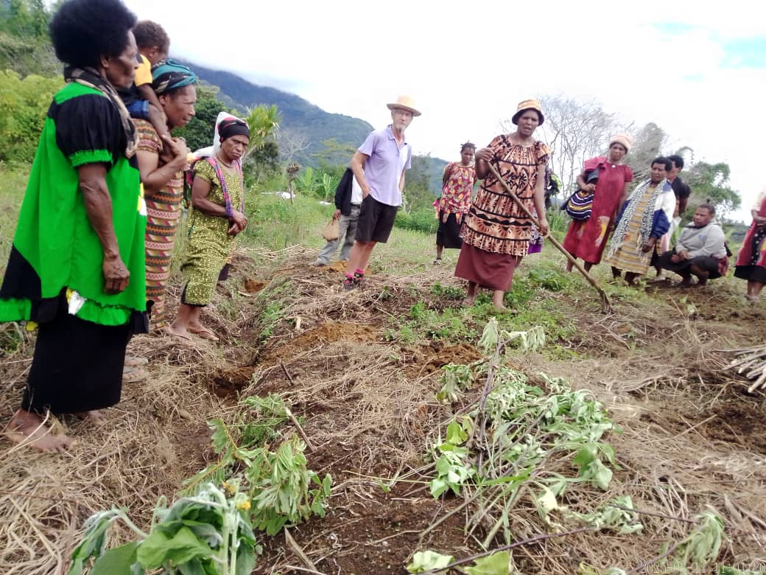Red Kona Leader Janet Saumi mulching a banana

Wild Sunflower, Tephrosia cuttings planted along edge of bed

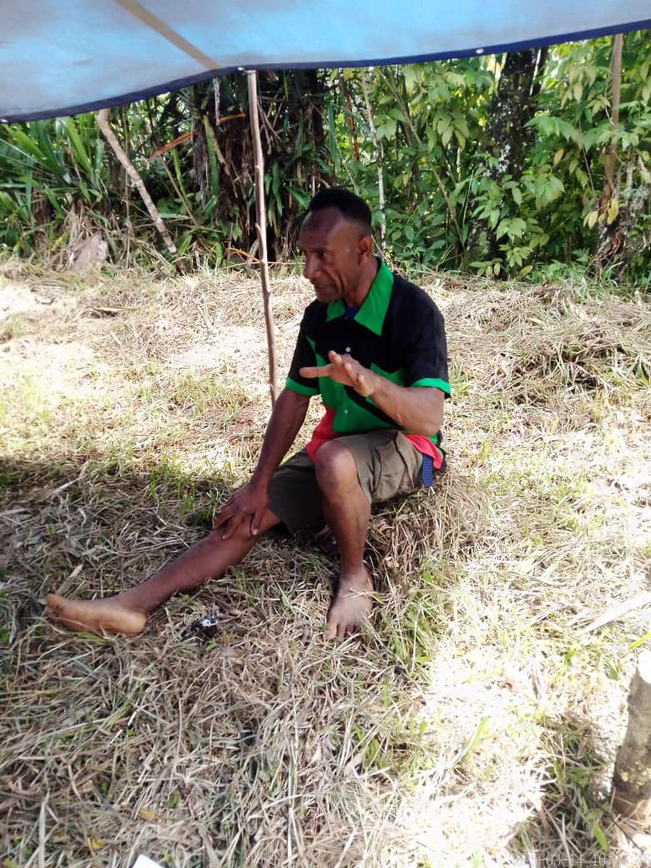

We are all looking at Wild Sunflower mulch on new mounds Red Kona Jonah supporting this Workshop